PHENIKAA UNIVERSITY

PHENIKAA SCHOOL OF COMPUTING



WEEKLY REPORT

TOPIC: ELECTRONICS E-COMMERCE WEBSITE

Course Class : | Software Architecture-1-2-25 (N01)
Instructor : | M.Sc. Vũ Quang Dũng
Group : | 16
Group Members : | Nguyễn Tuấn Thiền - 23010571  Đặng Việt Anh – 23010689
Mục lục:
Lab 02
1. Abstract/Summary 3
2. Lab Specific Section: Layered Architecture Design 3
2.1 Activity Practice 1: Defining Layers and Responsibilities 3
2.1.1 Data Flow Definition 5
2.2 Activity Practice 2: Component Identification (Product Catalog) 6
2.2.1 Identify Components 6
2.2.2 Define Interfaces 7
2.3 Activity Practice 3: UML Component Diagram Modeling 9
2.3.1 UML Component Diagram: Product Catalog Feature 9
2.3.2 Complete Layered Architecture Diagram 11
2.4 Detailed Interface Contracts (Supplement) 11
2.5 Dependency Injection Configuration (Supplement) 12
2.6 Request Flow Sequence 13
3. Architectural Analysis and Trade-offs 14
3.1 Trade-offs of the Layered Pattern 14
3.2 Analyzing ASRs: Layered Architecture Evaluation 14
4. Conclusion and Reflection 15
5. References 16

1. Abstract/Summary

This lab focuses on designing the Layered Architecture for the Electronics E-Commerce application, representing the system's static structure and component relationships. This is a crucial step before implementation in Lab 3.
Lab Objectives:
- Understand the principles and constraints of the Layered Architecture Pattern
- Define the four main layers and their responsibilities
- Identify the key components within each layer for the Product Catalog feature
- Model the logical view using UML Component Diagrams

2. Lab Specific Section: Layered Architecture Design

2.1 Activity Practice 1: Defining Layers and Responsibilities
Goal: Formally define the four layers and their roles within the Electronics E-Commerce architecture. The project implements a Modular Monolith with 8 modules (Catalog, Cart, Payment, Customer, Review, Content, Support, Admin). For Lab 02/03, the Layered Architecture pattern is demonstrated through a dedicated app/Lab03/ directory containing ProductController → ProductService → ProductRepository, which enforces strict layer separation via Dependency Injection and Interface contracts.
The Layered Pattern Rule: A layer can only interact with the layer directly below it (strict downward dependency).
Table 2.1: Four Standard Layers Definition
Layer | Purpose/Responsibility | Output/Artifact
1. Presentation Layer (UI/Web) | Handles HTTP requests, authentication, session management, and rendering the user interface (views). | Controllers (app/Lab03/Controllers/): ProductController. Modular Monolith controllers: ProductDetailController, CategoryController (Modules/Catalog/), CartController (Modules/Cart/), PaymentController (Modules/Payment/), AuthUserController (Modules/Customer/). Blade Views in resources/views/.
2. Business Logic Layer (Service/Domain) | Contains the core business rules, validation logic, and transaction management. Orchestrates data access. | Services (app/Lab03/Services/): ProductService (implements getProductById, createProduct, updateProduct, deleteProduct, searchProducts). Note: In the Modular Monolith, business logic is currently embedded in Controllers; the Lab03 implementation extracts it into a dedicated Service layer.
3. Persistence Layer (Data Access) | Responsible for mapping business objects to database entities and executing CRUD operations. | Repositories (app/Lab03/Repositories/): ProductRepository implements ProductRepositoryInterface (findById, getAll, create, update, delete, searchByName, exists). Eloquent ORM Models (app/Models/Models/): Product, Category, Order, User, Cart, Rating.
4. Data Layer (Database) | The physical database storage system (MySQL). | Database Schema (MySQL): products, category, oders, users, product_image, rating, article, contacts, transactions, supplier, outbox_messages, wishlists tables.

2.1.1 Data Flow Definition
The typical request flow for a customer viewing a product detail page follows this sequence:
Client Request -> Layer 1 -> Layer 2 -> Layer 3 -> Layer 4 -> Layer 3 -> Layer 2 -> Layer 1 -> Client Response
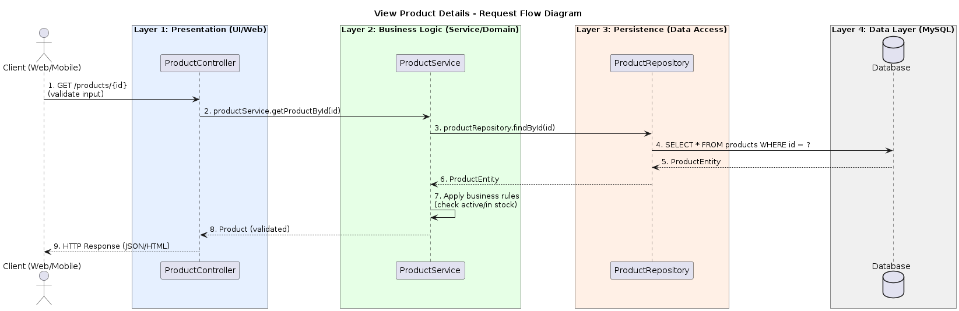
Figure 2.1: Request Flow Diagram - View Product Details

Table 2.2: Detailed Request Flow Steps
Step | From | To | Action/Description
2 | ProductController | ProductService | Call: productService.getProductById(id) (App\Lab03\Controllers\ProductController → App\Lab03\Services\ProductService)
3 | ProductService | ProductRepository | Call: productRepository.findById(id) (App\Lab03\Services\ProductService → App\Lab03\Repositories\ProductRepository)

2.2 Activity Practice 2: Component Identification (Product Catalog)
Goal: Break down the Product Catalog feature into concrete components that reside in the top three layers.

2.2.1 Identify Components
For the feature 'View Product Details', the following software components are identified:
Table 2.3: Component Identification for Product Catalog
Layer | Component Name | Responsibility
Layer 1 (Presentation) | ProductController | Located at app/Lab03/Controllers/ProductController.php (namespace App\Lab03\Controllers). Receives RESTful HTTP requests (GET /api/lab03/products/{id}). Delegates to ProductService via constructor injection. Returns JsonResponse. In the Modular Monolith, the equivalent is ProductDetailController in Modules/Catalog/.
Layer 2 (Business Logic) | ProductService | Located at app/Lab03/Services/ProductService.php (namespace App\Lab03\Services). Receives product ID from Controller. Enforces business rules: validates input (pro_name required, pro_price > 0, pro_category_id exists), calculates sale price (pro_total), marks products as “hot” if price > 10M VND, auto-deactivates if stock = 0. Calls ProductRepository via ProductRepositoryInterface injection. Returns transformed Product array.
Layer 3 (Persistence) | ProductRepository | Located at app/Lab03/Repositories/ProductRepository.php (namespace App\Lab03\Repositories). Implements ProductRepositoryInterface. Uses Eloquent ORM (App\Models\Models\Product) to execute queries against the “products” table. Methods: findById(id), getAllPaginated(perPage), getAll(), create(data), update(id, data), delete(id), searchByName(keyword), getByCategoryId(categoryId), exists(id).

2.2.2 Define Interfaces
The primary interfaces (method signatures) provided by each layer:
Table 2.4: Interface Definitions
Note: This table lists only the primary method signatures; additional methods can be documented as optional APIs.
Interface | Method Signature | Description
IProductService (for Layer 1) | array getProductById(int $id) | Returns transformed Product array with business rules applied (price calculation, active/hot status). Path: App\Lab03\Services\ProductService
IProductService | LengthAwarePaginator getAllProducts(int $perPage = 15) | Returns paginated LengthAwarePaginator of active products (pro_active=1), ordered by ID DESC
IProductService | array searchProducts(string $keyword) | Searches products by keyword in pro_name field. Returns array with keyword, count, and mapped products
IProductRepository (for Layer 2) | ?Product findById(int $id) | Returns Eloquent Product model or null. Maps to: SELECT * FROM products WHERE id = ?. Path: App\Lab03\Repositories\ProductRepository
IProductRepository | Collection getAll() | Returns Eloquent Collection of active products (pro_active=1), ordered by ID DESC
IProductRepository | Product create(array $data) | Creates new product record. Auto-generates pro_slug from pro_name. Sets defaults: pro_active=1, pro_hot=0, pro_sale=0

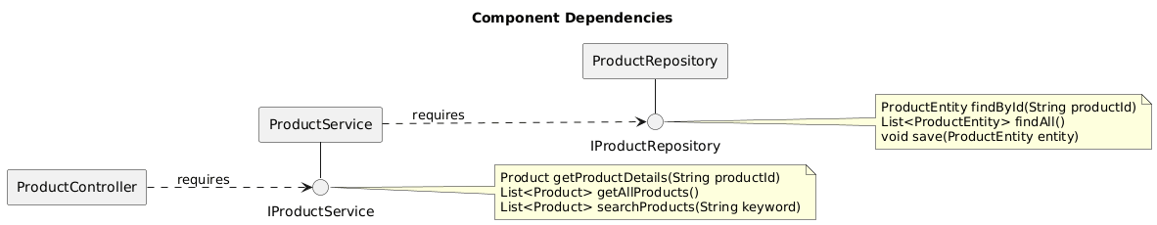
Figure 2.2: Component Dependencies with Interface Notation (Lollipop/Socket)

2.3 Activity Practice 3: UML Component Diagram Modeling
Goal: Create a visual model of the Layered Architecture using UML Component Diagrams.

2.3.1 UML Component Diagram: Product Catalog Feature
The following diagram shows the layered structure for the Product Catalog feature implemented in app/Lab03/, with Provided Interface (Lollipop) and Required Interface (Socket) notations:
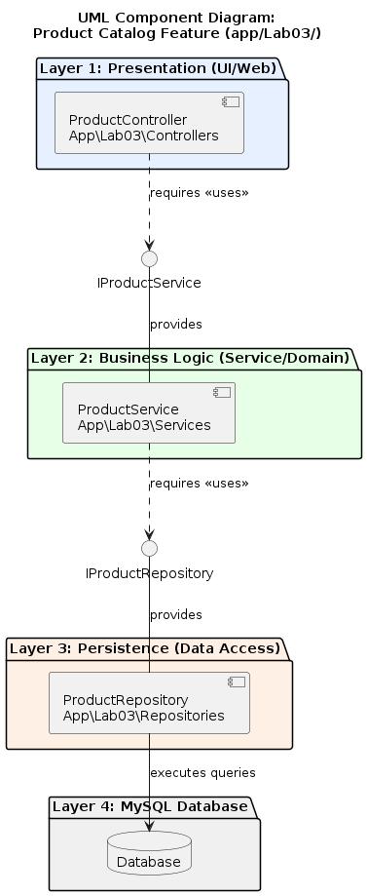
Figure 2.3: UML Component Diagram - Product Catalog Feature (app/Lab03/)
Diagram Elements Explanation:
- Three large stacked rectangles represent Presentation, Business Logic, and Persistence layers
- UML Component shapes (rectangle with two small rectangles) for ProductController, ProductService, ProductRepository
- Provided Interface (Lollipop): Circle on a line attached to ProductService labeled IProductService
- Required Interface (Socket): Semi-circle attached to ProductController that plugs into IProductService
- Strict Dependency: All arrows point strictly downward (Layer 1 -> Layer 2 -> Layer 3)

2.3.2 Complete Layered Architecture Diagram
The complete architecture mapping the Layered Pattern to actual source code. Left side: app/Lab03/ implements strict 3-layer separation (Controller → Service → Repository) for Lab 02/03. Right side: Modules/ (Modular Monolith with 8 modules) where Controllers call Eloquent Models directly:
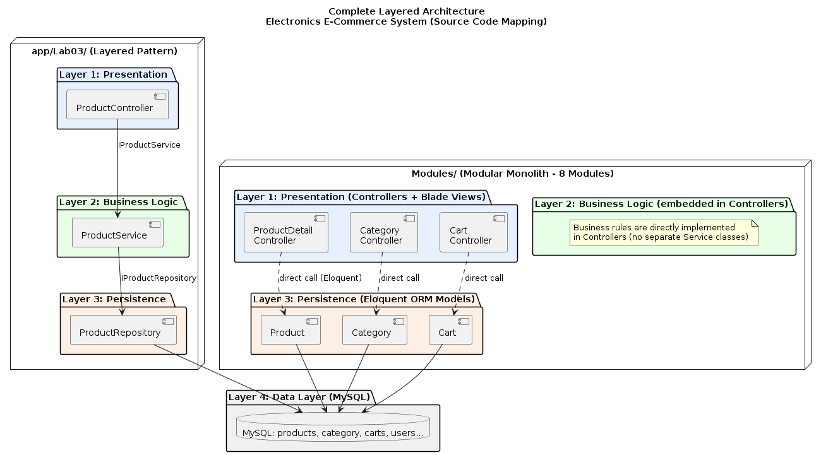
Figure 2.4: Complete Layered Architecture - Electronics E-Commerce System (Source Code Mapping)

2.4 Detailed Interface Contracts (Supplement)
The ProductRepositoryInterface defines 9 methods that form the contract between the Business Logic layer and the Persistence layer. This interface enables Dependency Injection and allows swapping implementations (e.g., from Eloquent to an API-based repository) without changing business logic.
File: app/Lab03/Repositories/ProductRepositoryInterface.php
interface ProductRepositoryInterface
{
public function getAllPaginated(int $perPage = 15);
public function getAll(): Collection;
public function findById(int $id): ?Product;
public function create(array $data): Product;
public function update(int $id, array $data): ?Product;
public function delete(int $id): bool;
public function searchByName(string $keyword): Collection;
public function getByCategoryId(int $categoryId): Collection;
public function exists(int $id): bool;
}

2.5 Dependency Injection Configuration (Supplement)
The Lab03ServiceProvider binds the interface to its concrete implementation, enabling constructor injection throughout the layered architecture. This is the glue that connects the layers without tight coupling.
File: app/Lab03/Providers/Lab03ServiceProvider.php
class Lab03ServiceProvider extends ServiceProvider
{
public function register(): void
{
// Bind Interface -> Implementation
$this->app->bind(
ProductRepositoryInterface::class,
ProductRepository::class
);
}

public function boot(): void
{
// Register Lab03 routes
$this->loadRoutesFrom(__DIR__ . '/../routes.php');
}
}

2.6 Request Flow Sequence
The following sequence describes the data flow for a GET /api/lab03/products/{id} request through all three layers:
1. Client sends HTTP GET /api/lab03/products/35
2. Laravel Router matches the route and dispatches to ProductController::show(35)
3. Presentation Layer (ProductController): Receives the request, extracts the ID parameter, delegates to ProductService::getProductById(35)
4. Business Logic Layer (ProductService): Calls ProductRepository::findById(35). If null, throws Exception with code 404. If found, calls transformProductData() to format the response.
5. Persistence Layer (ProductRepository): Executes Product::where('pro_active', 1)->find(35) via Eloquent ORM against MySQL database.
6. Response flows back: Repository -> Service (transform) -> Controller (JSON response with 200 OK)
Key principle: Each layer only communicates with the layer immediately below. Controller never accesses Repository directly.

3. Architectural Analysis and Trade-offs

3.1 Trade-offs of the Layered Pattern
Table 3.1: Layered Architecture Trade-offs
Advantages (Pro) | Disadvantages (Con)
Simplicity: Easy to understand and develop rapidly for small teams. | Scaling Inefficiency: If only the Catalog needs capacity, you must scale the entire monolithic application.
Testability: Each layer can be tested in isolation by mocking the layer below. | Deployment Coupling: A change in any layer requires redeploying the whole system.
Maintainability: Changes in one layer do not affect other layers if interfaces are preserved. | Performance Overhead: Each layer adds latency due to data transformation between layers.

3.2 Analyzing ASRs: Layered Architecture Evaluation
Evaluating how the Layered Architecture addresses the ASRs identified in Lab 1:
Table 3.2: ASR Evaluation for Layered Architecture
ASR | Layered Architecture Support | Rating | Future Action
ASR-1: Scalability | Weak. Must scale entire monolith even if only Catalog Module needs capacity. Mitigated by Modular Monolith (8 modules) + Strangler Pattern enabling future extraction of hot services. Kong API Gateway provides rate limiting. | WEAK | Consider Microservices
ASR-2: Security | Strong. Dual authentication guards (“admins”/“web”) enforce role separation at middleware layer (CheckLoginAdmin, CheckLoginUser). Payment Module isolates VNPay/MoMo/PayPal callback verification within PaymentController. | GOOD | Maintain current approach
ASR-3: Modifiability | Strong. Modular Monolith with Modules/{ModuleName}/ structure enables isolated changes. Adding PayPal only required changes in Modules/Payment/. Lab03 Service/Repository pattern further isolates business logic from data access via ProductRepositoryInterface. | GOOD | Maintain current approach

Conclusion: The Layered Architecture demonstrated in app/Lab03/ (ProductController → ProductService → ProductRepository) provides a clean separation of concerns and testability. However, it is fundamentally weak against our Scalability ASR (ASR-1). The project already mitigates this through the Modular Monolith structure with 8 isolated modules and the Strangler Pattern for gradual microservice extraction via Kong API Gateway.

4. Conclusion and Reflection
This lab successfully designed the Layered Architecture for the Electronics E-Commerce system following all requirements from Lab 2 and Lecture 2.
Key Deliverables Completed:
- Document 1: Table defining the purpose and output artifacts for all four layers, mapped to actual source code paths (app/Lab03/Controllers/, app/Lab03/Services/, app/Lab03/Repositories/, app/Models/Models/)
- Document 2: UML Component Diagrams showing actual components (ProductController, ProductService, ProductRepository) with interfaces (IProductService, IProductRepositoryInterface) and strict downward dependency flow
- Request Flow diagram tracing data movement through all layers
Key Learnings:
- Strict Downward Dependency: Components must only depend on the layer immediately below, ensuring maintainability
- Interface-Based Design: Lollipop (provided) and Socket (required) notations clearly define component contracts
- Separation of Concerns: Each layer focuses on its specialized task without knowledge of other layers' internals
- Trade-off Awareness: Layered architecture provides simplicity but sacrifices scalability

5. References
- Lab 2: Layered Architecture Design (Logical View) - Course Materials
- Lecture 2: The Layered Architecture Pattern - Software Architecture Course
- Lab 1 Report: Requirements Elicitation, ASRs, and Use Case Modeling

